Reading at home
Use the Oxford Owl website to read books that are the same as the colour band you are on.
https://www.oxfordowl.co.uk/
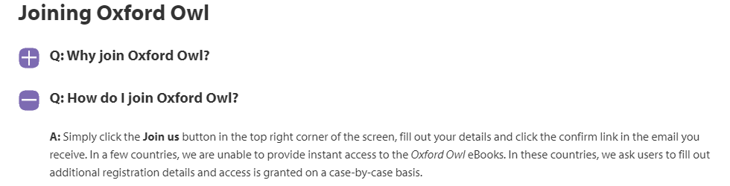
https://www.oxfordowl.co.uk/welcome-back/for-home
Once registered click here:
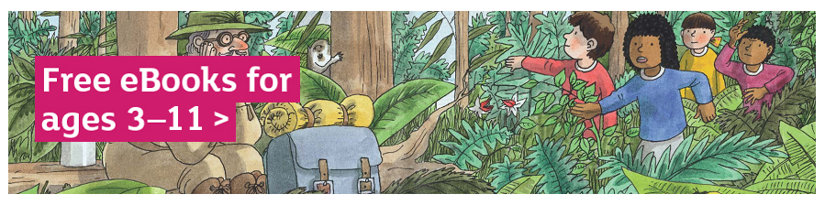
Then 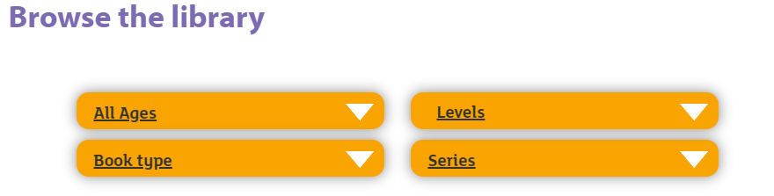
Click ‘Level’ then choose ‘Book Band.’ Choose your book band colour (same as the band that is stuck to the bottom of your current reading book or shown at the top – look for ‘Band Colour’) and choose a book to read. You could try the activity to go with it too.
When you have completed the book, you can complete the Accelerated Reader quiz at between 8.45 and 3pm.
https://ukhosted60.renlearn.co.uk/2249430/

